**i2si.v Document – Zachary Nelson**

**Interfaces:**

|  |  |  |  |
| --- | --- | --- | --- |
| **Signal Name** | **Direction** | **Bits** | **Comment** |
| **General** | | | |
| clk | in | 1 | Master Clock |
| rst_n | in | 1 | Reset |
| **I2S Input Interface** | | | |
| inp_sck | in | 1 | Digital Audio Bit Clock |
| inp_sd | in | 1 | Digital Audio Serial Data |
| inp_ws | in | 1 | Word Select |
| **Control/Status Register Fields** | | | |
| trig_fifo_overrun_clr | in | 1 | Reset FIFO Overrun |
| ro_fifo_overrun | out | 1 | Input Audio FIFO Overrun |
| rf_i2si_en | in | 1 | Serializer Enable Bit |
| rf_mux_en | in | 1 | Built in Self-Test (BIST) |
| rf_bist_start_val | in | 12 | Start Value |
| rf_bist_inc | in | 8 | Increment |
| rf_bist_up_limit | in | 12 | Upper Limit |
| **Streaming Audio Interface with Filter Block** | | | |
| i2si_rtr | in | 1 | Ready to Receive |
| i2si_rts | out | 1 | Ready to Send |
| i2si_data | out | 32 | Output Digital Audio |

**Functional Requirements:**

* Data Plane Requirements:
  + If the rf_bist_en control bit is true, the output of the block will be pre-defined such as a fixed sawtooth wave. This wave will be generated by the i2si_bist_gen.v module. If not, the input audio data will be queued into the FIFO buffer and later de-queued. The block will also need to convert audio serial data into 16-bit digital audio.
* Control Plane Requirements:
  + Serial data is transmitted in two’s complement with the Most Significant Bit (MSB) first. Serial data must be latched into the receiver on the leading edge of the serial clock signal. See Section 3.1 of I2S Specification Sheet for more details.
  + Support audio input sample rates of 8 kilosamples/sec – 48 kilosamples/sec.
  + The buffer sizing will have 2 or 3 storage elements which means we need a pointer that is 2 bits.
  + Overflow is a possibility because the FIFO buffer could be full when trying to input audio. In this case, the input will be ignored and the buffer will not change.
* Control and Status Interface Bit Descriptions:
  + Control Bits
    - i2si_ws: selects w­hat audio channel is being read. 0 = left channel, 1= right channel.
    - rf_i2si_en: i2s input is enabled. Is idle when rf_i2si_en = 0 and active upon the first high-to-low transition of word select (ws) and rf_i2si_en = 1.
    - rf_bist_en: built in self-test
  + Status Bits
    - ro_fifo_overrun: The FIFO buffer is full and no more can be added to the buffer
    - i2si_rtr: Output FIFO asserts ready to receive
    - i2si_rts: Write Client asserts ready to send

**Micro-Architecture:**

* Sub-blocks
  + i2si_synchronzier.v

|  |  |  |  |
| --- | --- | --- | --- |
| **Signal Name** | **Direction** | **Bits** | **Comment** |
| **General** | | | |
| clk | in | 1 | Master Clock |
| rst_n | in | 1 | Reset |
| **Synchronizer Input Interface** | | | |
| _sck | in | 1 | Digital Audio Bit Clock |
| _ws | in | 1 | Word Select |
| _sd | in | 1 | Digital Audio Serial Data |
| **Synchronizer Output Interface** | | | |
| sck | out | 1 | Delayed and Synced Serial Clock |
| sck_transition | out | 1 | Serial Clock Level to Pulse Converter |
| ws | out | 1 | Delayed and Synced Word Select |
| sd | out | 1 | Delayed and Synced Serial Data |

* + i2si_bist_gen.v

|  |  |  |  |
| --- | --- | --- | --- |
| **Signal Name** | **Direction** | **Bits** | **Comment** |
| **General** | | | |
| clk | in | 1 | Master Clock |
| rst_n | in | 1 | Reset |
| sck_transition | in | 1 | Serial Clock Level to Pulse Converter |
| **BIST Input Interface** | | | |
| rf_bist_start_val | in | 12 | Start Value |
| rf_bist_inc | in | 8 | Increment |
| rf_bist_up_limit | in | 12 | Upper Limit |
| **BIST Output Interface** | | | |
| i2si_bist_out_xfc | out | 1 | Transfer Complete |
| i2si_bist_out_data | out | 32 | Output Data |

* + i2si_mux.v

|  |  |  |  |
| --- | --- | --- | --- |
| **Signal Name** | **Direction** | **Bits** | **Comment** |
| **Data Lines Input Interface** | | | |
| in_0_data | in | 32 | Input 0 Data |
| in_0_xfc | in | 1 | Input 0 Transfer Complete |
| in_1_data | in | 32 | Input 1 Data |
| in_1_xfc | in | 1 | Input 1 Transfer Complete |
| **Enabled Bit** | | | |
| sel | in | 1 | Select Bit |
| **Multiplexer Output Interface** | | | |
| mux_data | out | 32 | Data Output |
| mux_xfc | out | 1 | Transfer Complete Output |

* + i2s_fifo.v

|  |  |  |  |
| --- | --- | --- | --- |
| **Signal Name** | **Direction** | **Bits** | **Comment** |
| **General** | | | |
| clk | in | 1 | Master Clock |
| rst_n | in | 1 | Reset |
| **Streaming Audio Interface with Multiplexer** | | | |
| fifo_inp_data | in | 32 | Input Data |
| fifo_inp_rts | in | 1 | Write Client Asserts Ready to Send |
| fifo_inp_rtr | out | 1 | Output FIFO Asserts Ready to Receive |
| **Streaming Audio Interface with Filter Block** | | | |
| fifo_out_data | out | 32 | Output Data |
| fifo_out_rts | out | 1 | Output FIFO Asserts Ready to Send |
| fifo_out_rtr | in | 1 | Read Client Asserts Read to Receive |

* + i2si_deserializer.v

|  |  |  |  |
| --- | --- | --- | --- |
| **Signal Name** | **Direction** | **Bits** | **Comment** |
| **General** | | | |
| clk | in | 1 | Master Clock |
| rst_n | in | 1 | Reset |
| **Deserializer Input Interface** | | | |
| sck_transition | in | 1 | Serial Clock Level to Pulse Converter |
| in_sd | in | 1 | Digital Audio Serial Data |
| in_ws | in | 1 | Word Select (Left/Right Audio Channel) |
| **Deserializer Output Interface** | | | |
| out_lft | out | 16 | Left Audio Channel |
| out_rgt | out | 16 | Right Audio Channel |
| out_xfc | out | 1 | Read Data Transfer Complete |
| **Control/Status Register Fields** | | | |
| rf_i2si_en | in | 1 | I2S input Enabled |

* Block Diagram

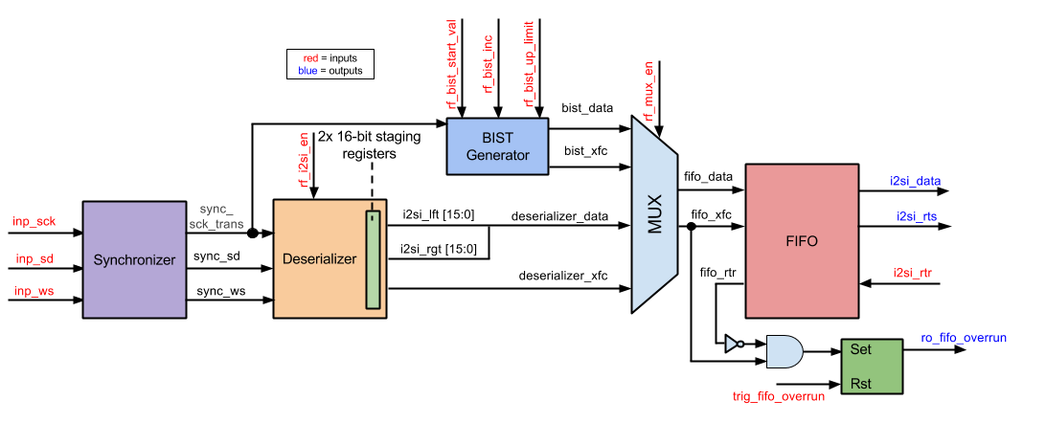

**Design:**

* As-Built Design Features
* Number of Gates and Flip-Flops
* How fast can it run?

**Verification:**

* Testbench
* Test Plan
  + The first thing that needs to be created for a test is a stream of bits that represents an I2S audio signal. More specifically, data for the 3 I2S inputs will need to be created.
  + The block needs to be tested when the i2si_en bit is true and false. If the bit is false the I2S block should not input any data.
  + The block needs to be tested when the BIST is enabled. In this case only the predefined waveform will be sent to the filter module.
  + The block needs to be tested when the FIFO overflow and underflows. The block should be able to handle these situations without any problems.